Amaro Terrazas
Professor Ostrowski
CS-340
31 May 2025
4-1 Create and Read in Python
Task 1:
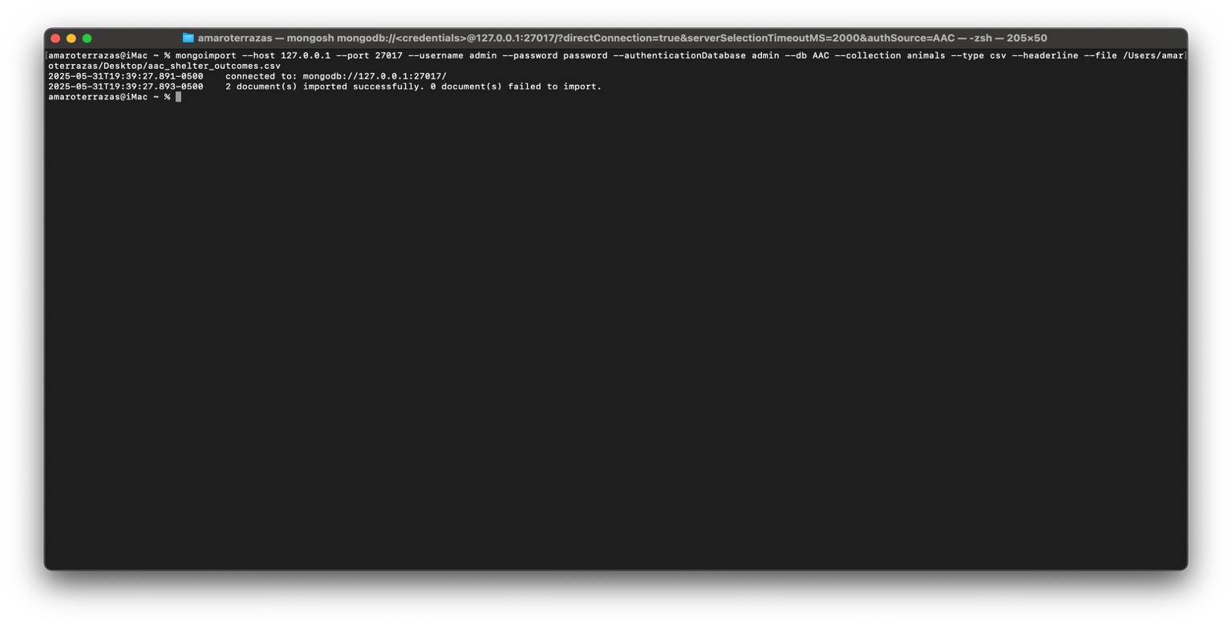
Task 3:
